**ACTIVITY 7:** **Complex and Subqueries**

**Objective:**

To know how to write complex queries and subqueries

**Materials:**

PC or Laptop

WAMP/XAMPP Installer

Web Browser or CLI

**Background**

A MySQL subquery is a query nested within another query such as SELECT, INSERT, UPDATE or DELETE. In addition, a MySQL subquery can be nested inside another subquery.

A MySQL subquery is called an inner query while the query that contains the subquery is called an outer query. A subquery can be used anywhere that expression is used and must be closed in parentheses.

Based on the previous laboratory activity about aggregate functions, you have probably encountered this note:

Your answer to above items would probably be:

**MIN**. Find the cheapest female dog. Show the gender, type and price.

1. You might have this solution but it seems like it ONLY gives right value for gender and type which are ‘female’ and ‘dog’ respectively. But when you try to observe, the cheapest price is actually 135.10. Yet we don’t know if it is a female.

1. So, let us look at the gender and type of that pet. Well, according to our display below it is indeed a female but it is fish. We all know that we need to find the female dog whose price is the cheapest.

1. Now, if we are going to look at our next query 135.10 is the price of the cheapest female dog.

1. So, I guess it is really impossible to answer using simple query. But of course, everything is ‘queryable’ but it is matter of invoking right query to produce accurate results. I don’t guarantee these are the **BEST and MOST RIGHT** solutions you will have. Let me try,

**Solution #1: My first solution is a little bit complex because I used combinations of where clause plus order by sort and a limit operator. Which I believe is producing desired result. Hence, it is an example of complex query.**

**Solution #2: My second solution is an example of subquery where a query has another query inside of a query. I guess you will see it below. Observe.**

**MAX**. Find the eldest male dog. Show the gender, type and age.

**Instructions:**

1. Find the eldest male dog. Show the gender, type and age.

**My command prompt:**

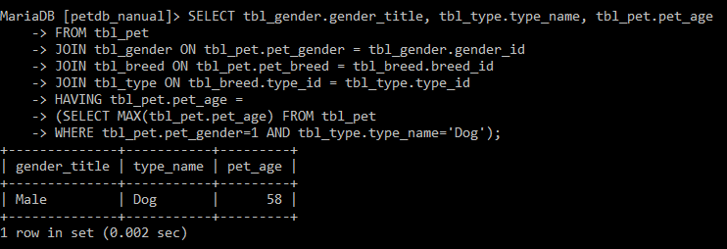

1. Find the eldest female cat who are active. Show the gender, type and age.

**My command prompt:**

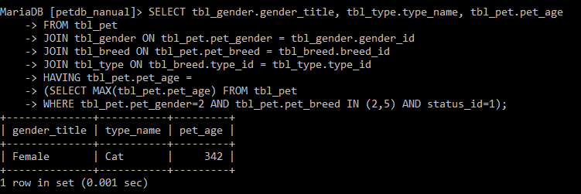

1. Show active dogs whose age is more than 20.

**My command prompt:**

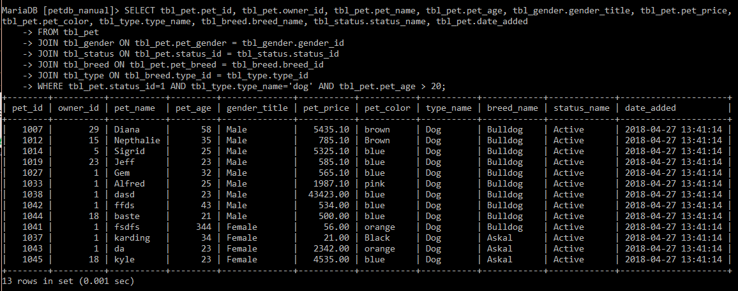

1. Project all pets whose status are lost except cats and dogs.

**My command prompt:**

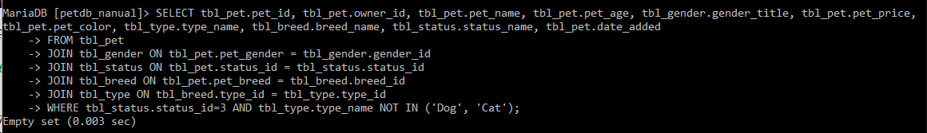

1. View owners who are female single whose age is below 40.

**My command prompt:**



1. Show how many male and female pets who are dog.

**My command prompt:**

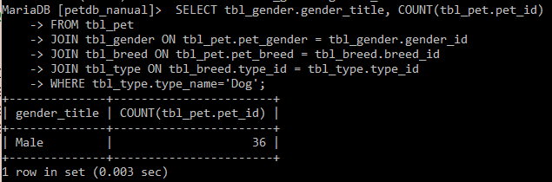

1. Display pets’ status and its total number

**My command prompt:**

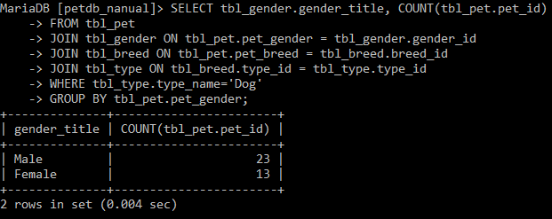

1. Show breeds of type dog.

**My command prompt:**

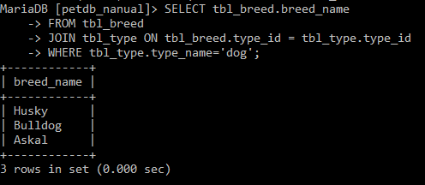

1. Show color of pets, display how many pets each color.

**My command prompt:**

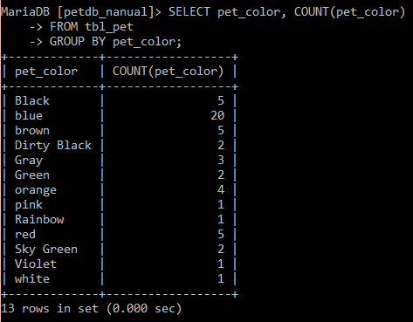

1. Show the top 5 most expensive pets who are male dogs.

**My command prompt:**

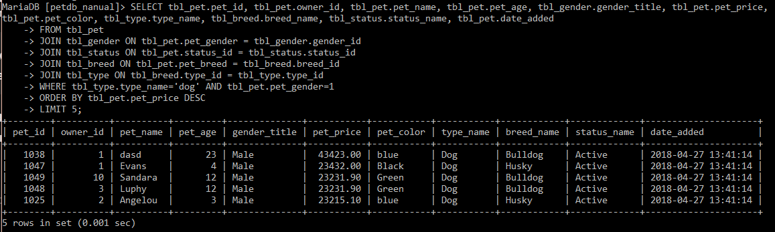

1. Show how many breeds of type cat, then display how many per breed.

**My command prompt:**

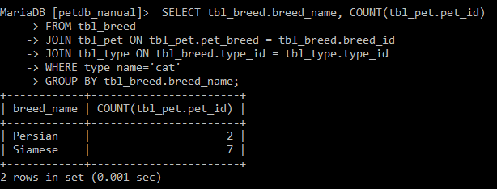

1. Show owner who are deceased and single.

**My command prompt:**

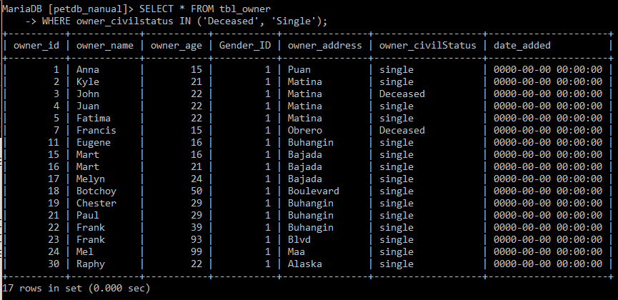

1. Count how many owners live per city address.

**My command prompt:**

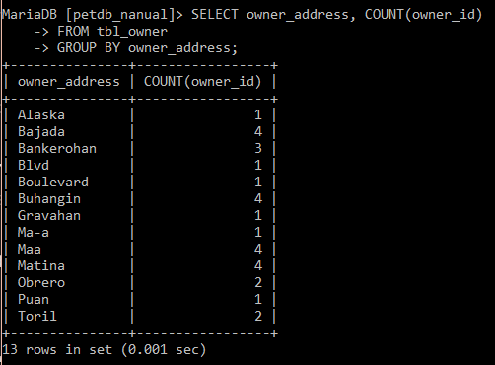

1. Count how many owners filter by status.

**My command prompt:**

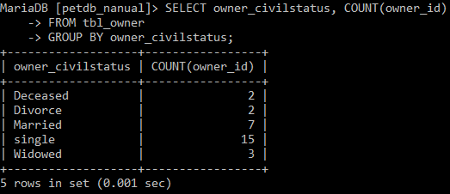

1. Show owner who are single in Obrero and Bankerohan.

**My command prompt:**

